|  |  |  |  |
| --- | --- | --- | --- |
|  | 11/15/2013 |  | |
|  | |  | |
| Report for Week 1  *Introduction to the basics* | | | |
|  |  | |  |
|  |  | | Stefan Hesselman, Ruta Merkyte, UvA - HCM |

Report for Week 1

Introduction to the basics

# Step A

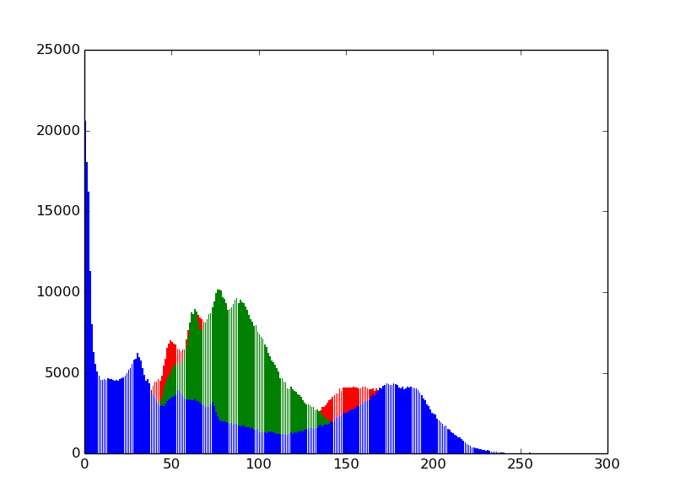

**Figure 1.**

# Step B

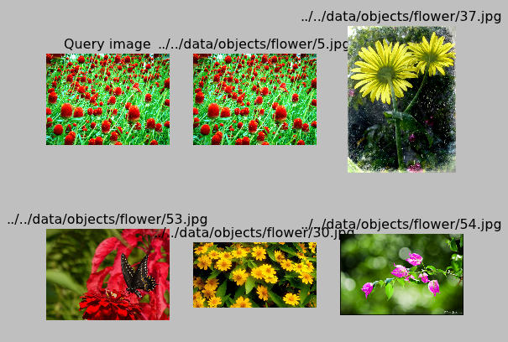

Image 5: Euclidean

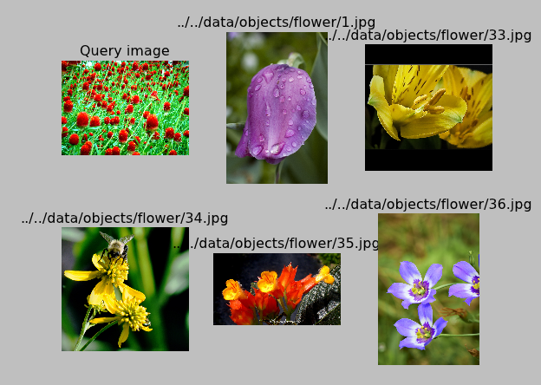

image 5: Hellinger

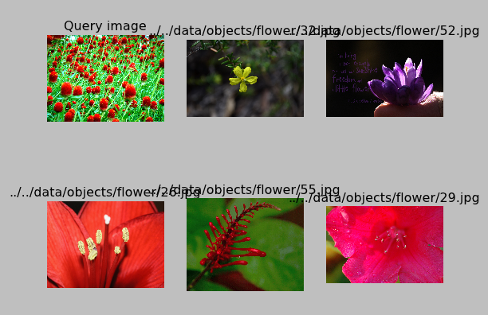

Image 5: intersect

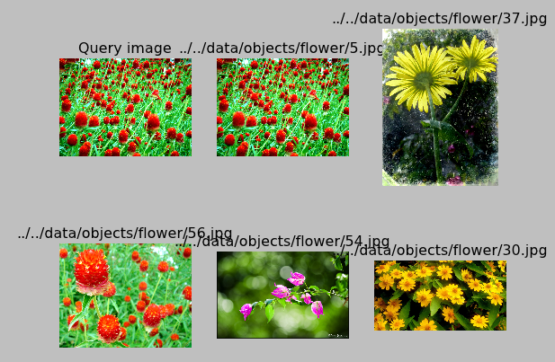

image 5: chi2

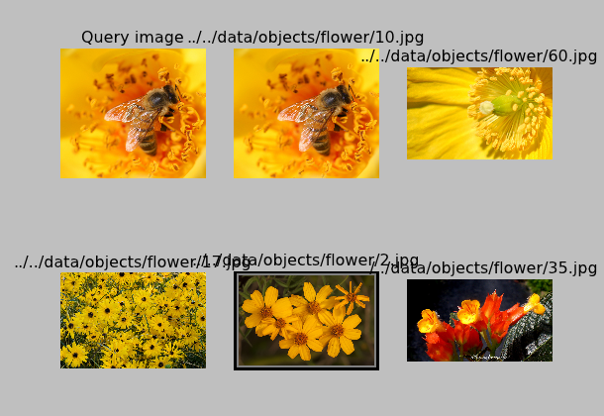

image 10: Euclidean

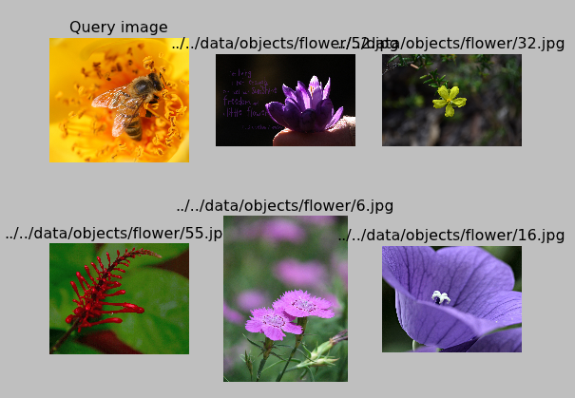

image 10: intersect

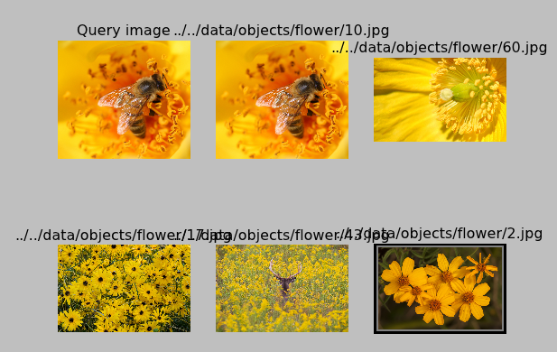

image 10: chi2

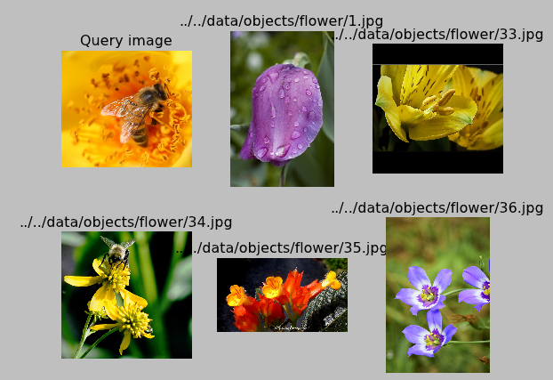

image 10: hellinger

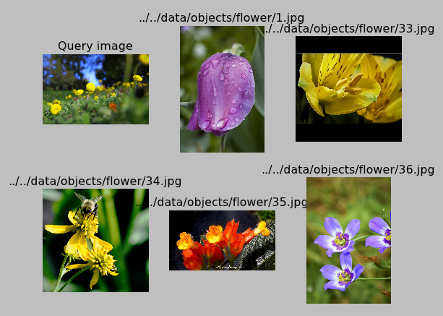

image 15: hellinger

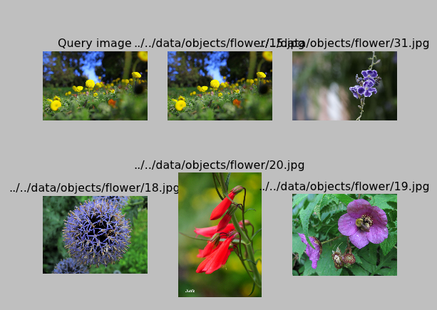

image 15: Euclidean

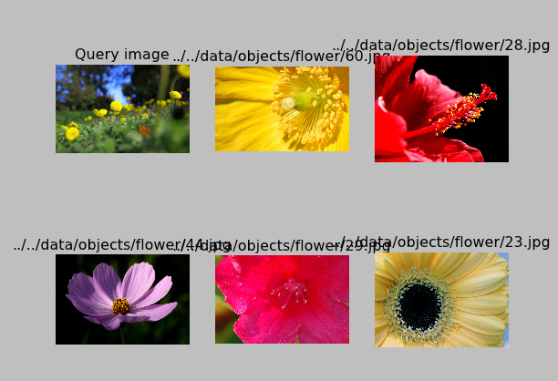

image 15: intersect

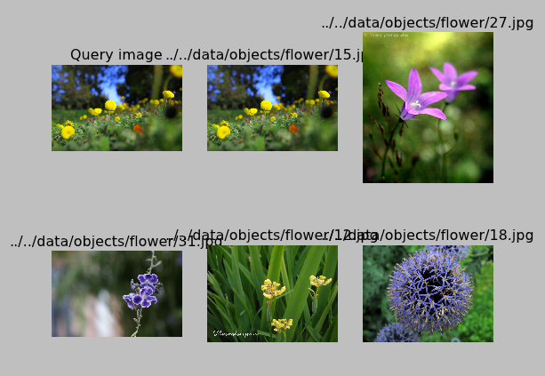

image 15: chi2

## Observations

We have found that by using different calculations we have received results where similarities were few. One interesting observation is the high reoccurrence of image 15 in all of the results.

# Step C

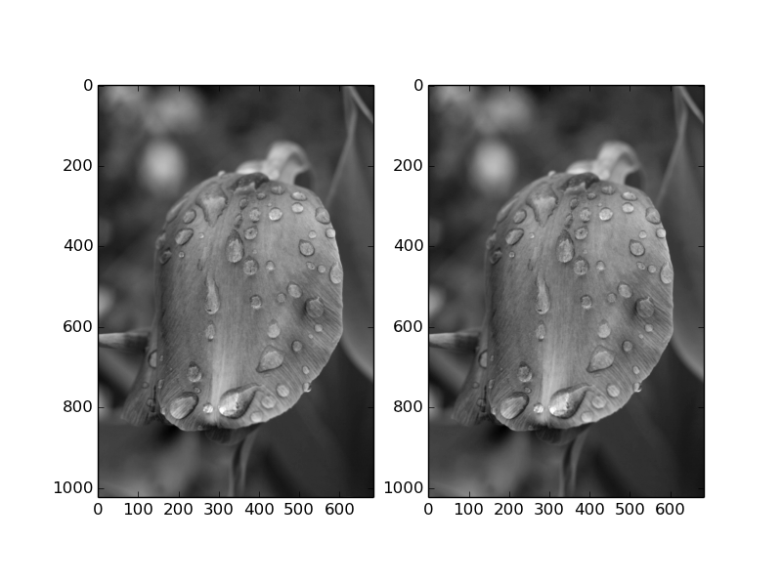

**Figure x.**

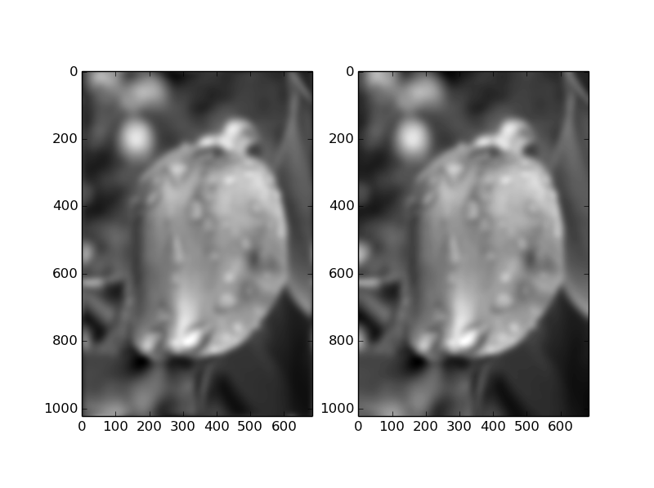

**Figure x.**

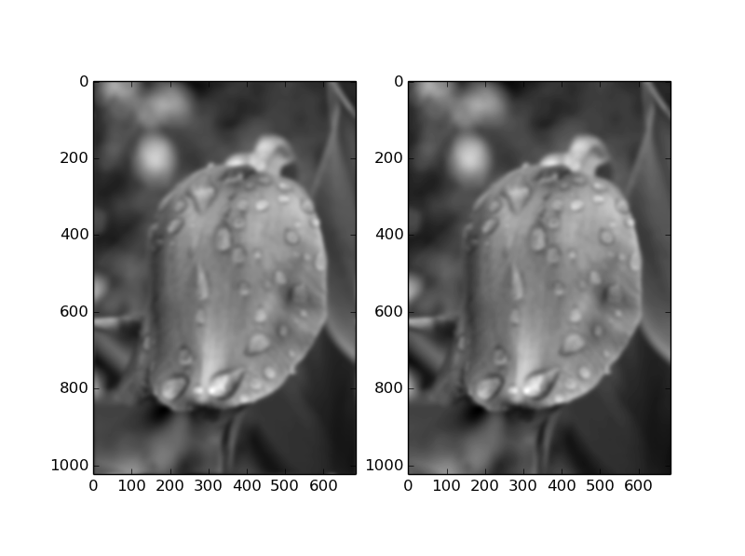 **Figure x.**

# Step D

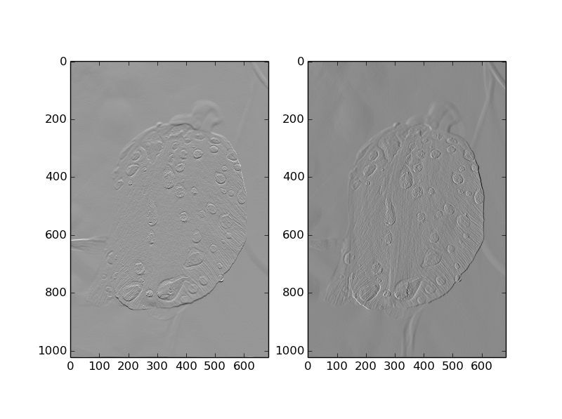

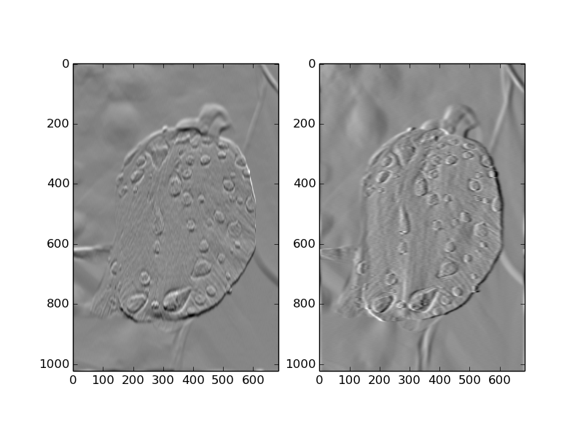 **Figure x.**

**Figure x.**

**Figure x.**

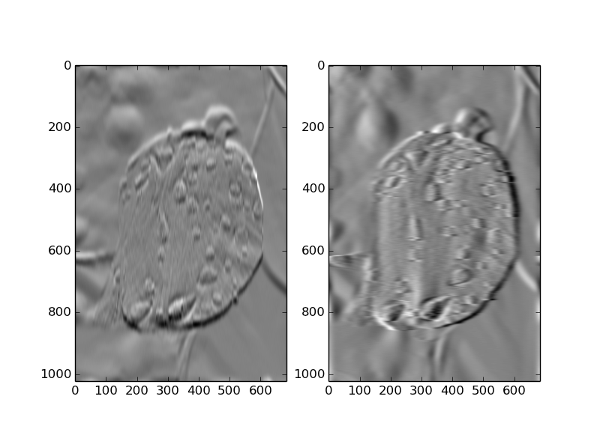

# Step E

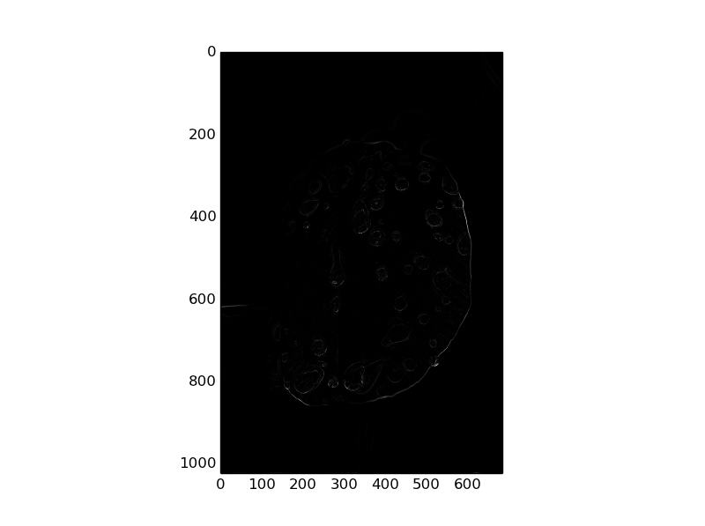

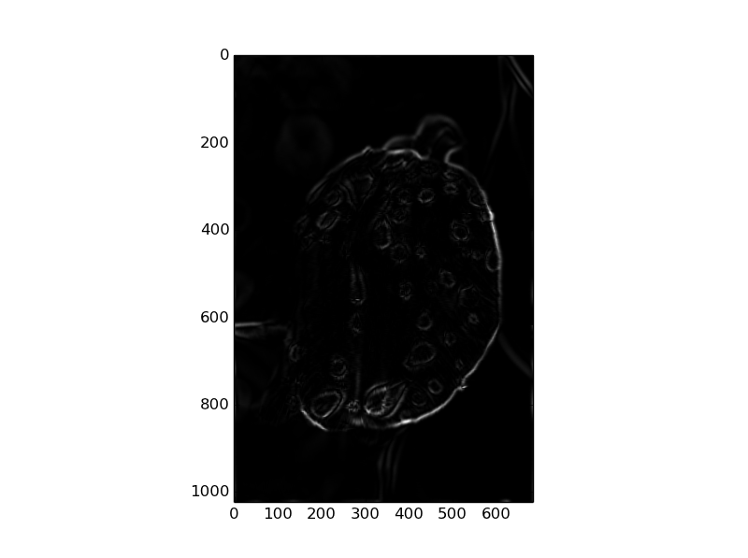

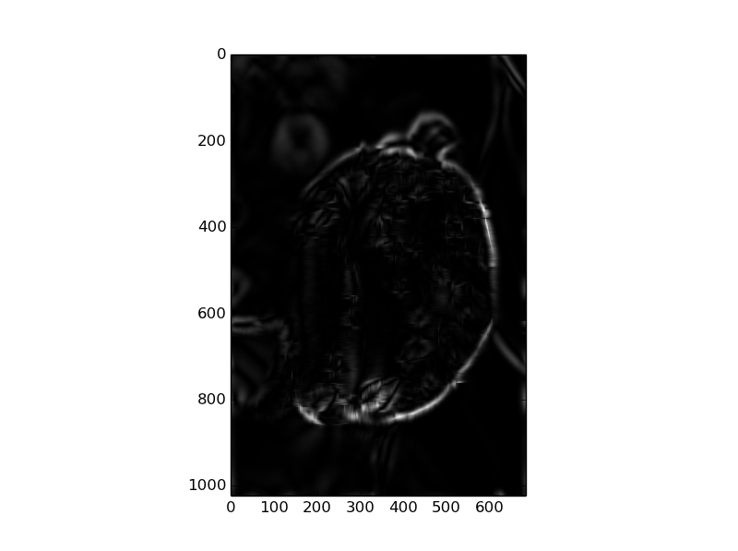

## Observations

Because of the pre-existing Gaussian that was applied in the original image, we believe that this creates and emphasis on the edges of the flower. Notably the parts where the sharpness of the flower is very high.